New Technology Artifact Assignment
Briana C. Croal
Liberty University

New Technology Artifact Assignment
Selected Technology
Google Docs
Google docs are one of the google apps that are used in the teaching and learning process. Google Docs can be described as a word processor that is available online. This technology enables individuals to create and format any document online (Ishtaiwa & Aburezeq, 2015). Every individual with a google account can easily access google docs. Therefore, it is crucial to note that this technology is a web-based application that can be accessed by multiple devices such as computers and mobile phones. This technology is also supported by several browsers such as Google Chrome, Microsoft Edge, Apple Safari, Internet Explorer, and Mozilla Firefox.
Sample of how it will be used
The images below show how google docs enhance collaborative learning through peer editing among other activities (Oxnevad & Author, 2012).
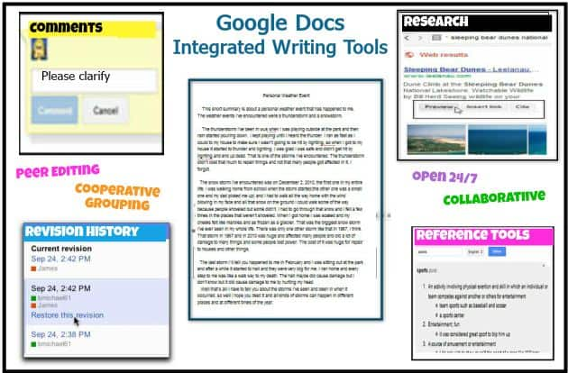

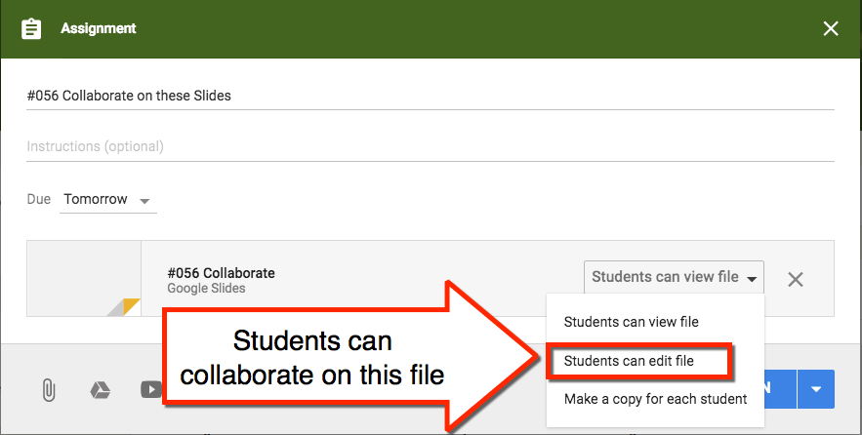
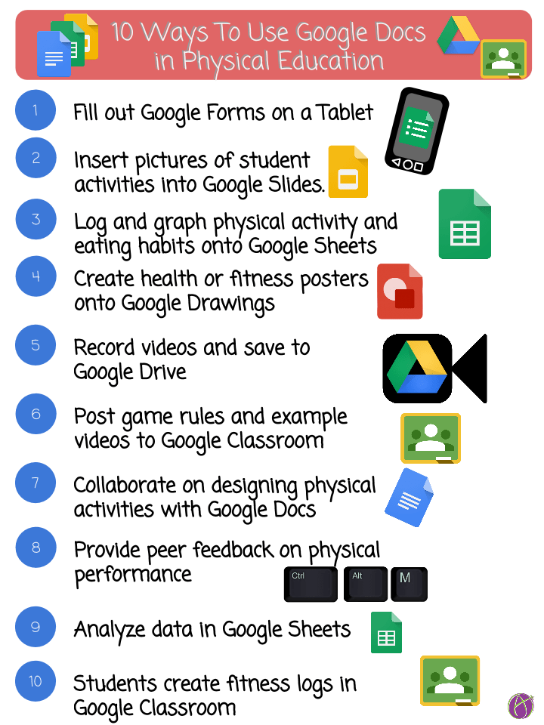

Reasons for Selecting this Technology
One of the reasons why I selected this technology is because students can easily access the database 24/7, regardless of their geographical location. This technology improves flexibility in learning because it only requires students to have access to the internet. Students are also able to access any document at any time. Another reason for selecting this technology is that any student is free to edit or delete any information that they feel is inappropriate or incorrect (Ishtaiwa & Aburezeq, 2015). For example, in the case of a group work assignment, a student can correct an answer after discussing it with peers. Therefore, this technology is important because it enables group members to make necessary changes. Another advantage is that this application is free to access. Students are not required to pay anything when using google docs. Therefore, the organization will not waste resources in procuring experience technologies to enhance collaborative learning.

Kahoot
Kahoot is a game-based platform that enables individuals to learn through games (Marello, 2014). Educators can test students with multiple-choice quizzes since they are accessible via the Kahoot app or web browser.
Sample of how it will be used
This image described the collaborative cycle of Kahoot in learning environment (Marello, 2014).
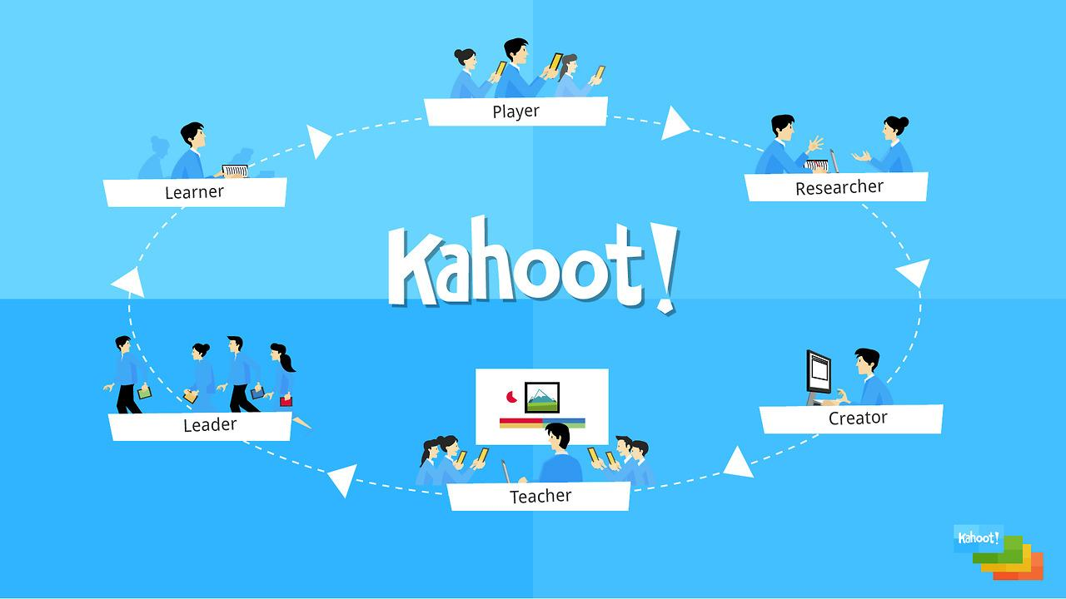
Reasons for Selecting this Technology
I selected Kahoot as another classroom technology because it allows students to make their quizzes, create puzzles, and also present those puzzles. All of these activities promote active learning. Students are also able to host live games and share their knowledge (Marello, 2014).

FlipGrid
FlipGrid is a classroom technology that creates a video discussion community (Merrill, 2021). With this technology, students can easily make videos and share them with one another. Students are also able to respond to various questions in video format.
Sample of how it will be used
The image below indicates the importance of FlipGrid in a classroom setup (Merrill, 2021).
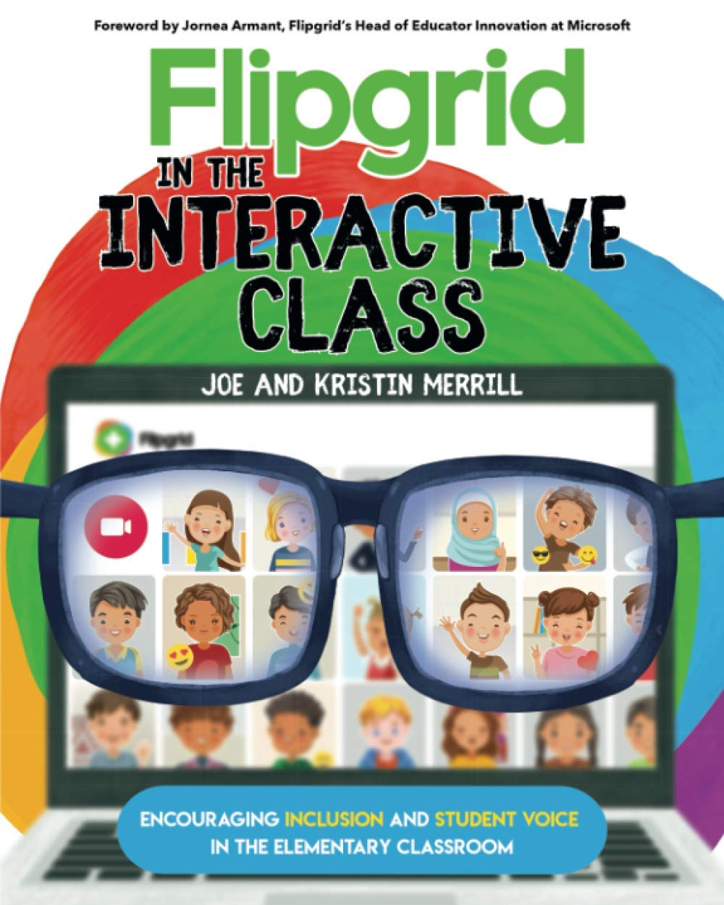
Reasons for Selecting this Technology
One of the reasons why I selected this technology is because it improves student's interactions. Students are able to make several videos in response to the asked questions. Also, this technology improves student's communication skills because they are expected to record a video and share it with other classmates (Merrill, 2021). This technology is also easier to use. For I stance, the teacher only signs up and then creates a grid that acts as a platform that students use to exchange their videos. FlipGrid also makes it possible for students to respond to each other (Merrill, 2021). The peer-to-peer option enables students to give direct replies to one another. Therefore, peers can compose video responses and then give appropriate feedback upon completion of the exercise.

References
Ishtaiwa, F. F., & Aburezeq, I. M. (2015). The impact of Google Docs on student collaboration: A UAE case study. Learning, Culture and Social Interaction, 7, 85-96.
Marello, J. (2014). Kahoot is a Fun Free Game-Based Classroom Response System. Retrieved 7/17/2021. From https://www.emergingedtech.com/2014/07/kahoot-game-based-classroom-response-system/
Merrill, K. (2021). Flipgrid in the Interactive Cass: Encouraging Inclusion and Student Voice in the Elementary Classroom.
Oxnevad, S. & Author, G. (2012). 5 Ways to Use Google Docs in the Classroom. Retrieved 7/17/2021. From https://www.gettingsmart.com/2012/12/5-ways-to-use-google-docs-in-the-classroom/

